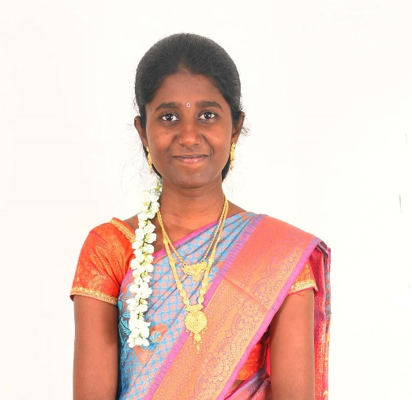 |  | About Family  A family of four, with the father, Mr. A.S. Sundarraju, a retired Higher Secondary School Headmaster, and the mother, Mrs. S. Rajeswari, a homemaker. The elder brother is serving as the Managing Director of IndianMark Industries, Coimbatore.  The family is settled in Ayingudi, Aranthangi, Pudukkottai.
  DHIVYA BHARATHI S
  Age | : | 28 Years and 2 months
  Education | : | B.Sc. Agriculture
  Contact Number | : | +91 94884 13441
Personal Information
Height | : |  | 5’4”
Weight | : |  | 46 Kg
Body Type | : |  | Slim
Spoken Languages | : |  | Tamil (Mother Tongue), English
Lives In | : |  | Ayingudi South, Aranthangi, Tamil Nadu
Eating Habits | : |  | Non-Vegetarian
Religion | : |  | Hindu
Caste | : |  | Ambalakarar
Gothra(m) | : |  | Kalahastri
Dosha(m) | : |  | No Dosham
Date Of Birth | : |  | 09 March 1997 Time: 11:15 AM
Star | : |  | Puratathi
Raasi | : |  | Kumbam
Place Of Birth | : |  | Arantangi (Tk), Pudukkottai, Tamil Nadu
Employment | : |  | Works in Department of Industries & Commerce (Government of Tamil Nadu), Guindy, Chennai
Income | : |  | ₹4L-5L per annum
Occupation | : |  | Administrative Professional (Typist)
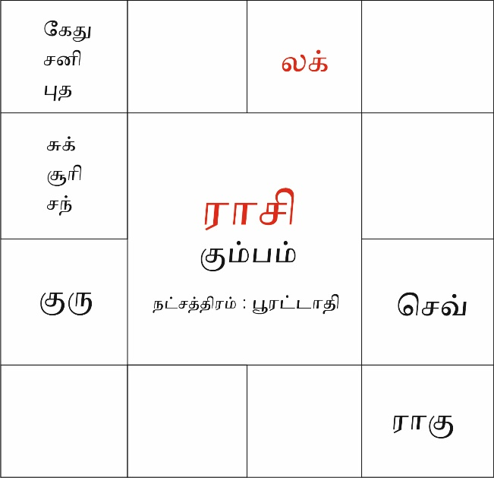 |  |  |  | 